
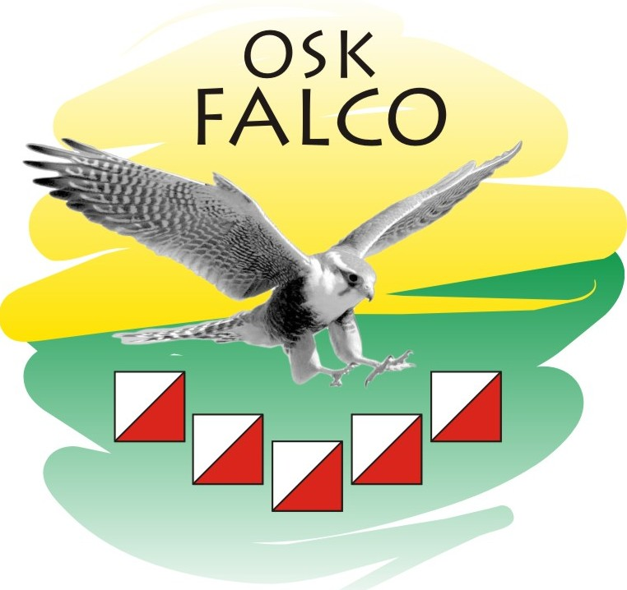
FALCO-TAKAS
TRAIL ORIENTEERING
TempO multi-course

3 days, 1+3 courses Trail orienteering competitions
21-23 June, 2013, Druskininkai, Lithuania

OSK „Falco“
INVITATION

FALCO-TAKAS TempO competitions is organized to promote this course between those who participate in usual orienteering courses. We expect this event will became traditional part of “Takas” event. TempO course can be interesting challenge for foot and MTB orienteering athletes and for those who specializes in Trail orienteering. The competitions are organized so that runners and MTB event athletes could participate in them after they have finished their courses. TempO event do not requires a lot of physical efforts, but technically challenging and can be relaxing after traditional courses.
Event programme

June 21, 2013
12:00 – 16:00 | Arrival, Registration | Competition stage center
12:00 – 15:00 | TempO model | Kermušijos forest
15:00 – 17:30 | TempO course 1 | Kermušijos forest

June 22, 2013
12:00 – 13:00 | Arrival, Registration | Competition stage center
13:00 – 15:30 | TempO course 2 | Druskininkai

June 23, 2013
11:00 – 12:00 | Arrival, Registration | Competition stage center
12:00 – 14:30 | TempO course 3 | Druskininkai
15:00 – 16:00 | Prize giving and Closing ceremony | Competition stage center
The timetable is prognostic and can be changed. It will be matched to runners and MTB courses timetables to give the opportunity for athletes to participate in both courses.

Links to competition stages:
TempO model and TempO 1 – 21-06-2013:
https://maps.google.com/maps?daddr=53.996481,24.101425&hl=lt&sll=53.996481,24.101536&sspn=0.009977,0.01929&t=h&mra=mift&mrsp=1&sz=16&z=16
TempO 2 – 22-06-2013:
https://maps.google.com/maps?daddr=54.029049,24.004261&hl=lt&ll=54.0231,23.995857&spn=0.039884,0.077162&sll=54.025369,24.001737&sspn=0.019941,0.038581&t=h&doflg=ptk&mra=mift&mrsp=1&sz=15&z=14
TempO 3 – 23-06-2013:
https://maps.google.com/maps?daddr=54.009578,23.977509&hl=lt&ll=54.011703,23.976116&spn=0.019947,0.038581&sll=54.009616,23.9772&sspn=0.004987,0.009645&t=h&doflg=ptk&mra=mift&mrsp=1&sz=17&z=15

Classes, results, awards and start lists

TempO – competitors are not divided to separate classes nor by gender, nor by age.
TempO model course is for evaluation purposes. Personal results and answers are presented at the place.
Results are summed up for: 1, 2 and 3 courses. Competitors are ranked according to their total corrected time, which is the sum of the times taken at each control station plus 30 seconds penalty for each wrong answer. Any control that is deemed to be unfair and voided the entire control station is voided.
In each course individually winners of 1-3 places will be awarded diplomas. In summed up result winners of 1-3 places will be awarded with diplomas, medals and memorable prizes.
Start lists with sequence order will be generated for those who registered in advance. Ones who will be late or registrated at the start point will be allowed to start after start list ends by free order.
Author of courses - Andrius Jovaiša (1d. and 3d.), Evaldas Liekmanis (2d.).
Adviser – Algimantas Dambrauskas

Registration and start fee

Registration by mail: info@oskfalco.lt or andrius.jovaisa@gmail.com
There is two deadline for registration and start cost:
 | Up till 16-06-2013 |  | Later up till start
 | 4 course fee | 1 course fee | 4 course fee | 1 course fee | Model fee
Adults | 30 Lt | 10 Lt | 60 Lt | 20 Lt | 10 Lt
Children up till 16 years | 15 Lt | 5 Lt | 30 Lt | 10 Lt | 5 Lt
For competitors at “Takas 2013” | 15 Lt | 5 Lt | 30 Lt | 10 Lt | 5 Lt
The participant can participate in all 4 courses or in any course individually.
Payment is acceptable in cash at competition stage center or by bank transfer to account pointed below. The payment sum depends on registration date, so please hurry to register and pay less.
Lithuanian national currency is Litas (LTL). At the moment of payment exchange rate 1€=3.33LTL is used. The payable sum in Euro: LTL*3/10

Account holder of Trail-O event:
OSK “Falco”
Inc code: 302746375
acc#: LT797044060007814548
Bank: bic#: 70440, AB SEB bankas, SWIFT#: CBVILT2X

Additional information and contacts

Information on „Takas 2013“ event:
http://www.oktakas.lt/index.php?page=en/event/takas2013

Event organizer:
OSK “Falco”
Kauno street 59, LT-54467, Ramuciai, Kauno raj., LITHUANIA
E-mail: info@oskfalco.lt
Person in charge: Andrius Jovaiša
Phone: +370 68788771, andrius.jovaisa@gmail.com

